**Cellular Automaton**

**Requirements specification**

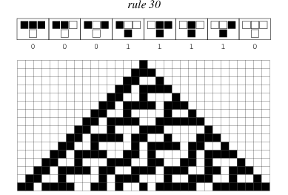

*Example of cellular automaton from*

*http://mathworld.wolfram.com/CellularAutomaton.html*

User stories:

* As a customer, I want to have a possibility to introduce new rules which determine new state of each cell, so I can obtain various results.

* As a customer, I want to have a possibility to save my introduced rules, so I don’t have to memorize them if I want to repeat them later.
* As a customer, I want to have a set of rules, so I can see how program works without introducing my own rules.
* As a customer, I want to have a possibility to change previously introduced rule, so I can correct them if I made a mistake during creating them.
* As a customer, I want to see the change of the grid step by step, so I can see how rule affect the grid of cells.
* As a customer, I want to see the change of the grid after n steps, so I can see the change after for example 30 steps without waiting.
* As user closing the application, I want to be asked if I want to save my changes, so I am sure that I will not forget to save.
* As user starting the application, I want to see the grid with cells in initial state and have an option to set the rule from available rules, so I can see how the grid changes.
* As a customer I want to have a possibility to observe whole grid when the grid is out of the view, so I don’t miss any changes of the grid.